5)Javascript Engine

Here javascript engine was explained

Javascript engines avalaible- chakra, spider monkey and v8. V8 is fastest and was relaeased in 2008. Very first js engine was written by breden eich and it later became spider monkey.

7)Inside Engine

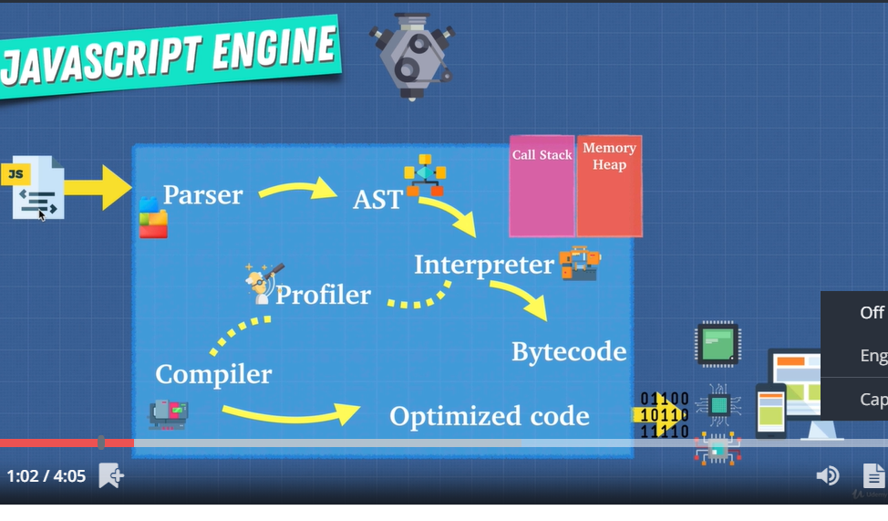

13)Writing optimized code

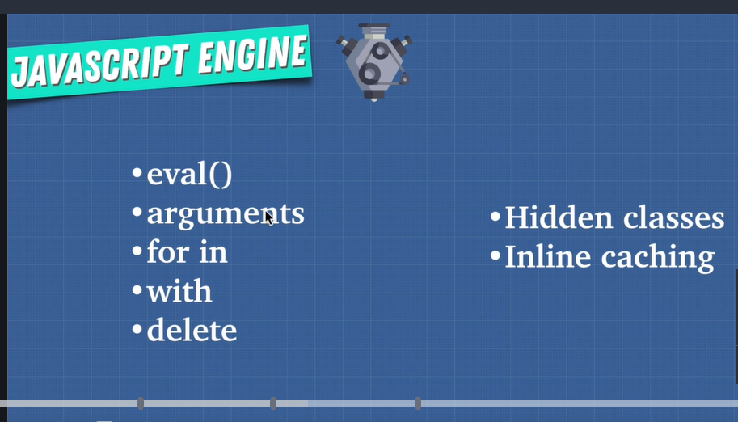

Do not use abve things, they are bad for optimization.

15)Call Stack and Memory heap

Here we saw what is call stack and memeory heap

16)Stack overflow

17)Garbage Collection

18)Memory leak

Check links in things to remeber

21)Javascript Run time

Jaavscirpt is synchrous that will make it slow. So we never use just javascript engine, we also have javascript runtime.

Sos what is happening is is browser is running in background as synchronous javascript is running.

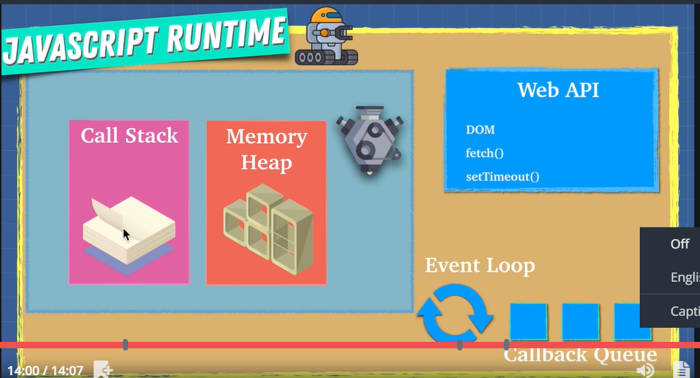

22) Nodejs

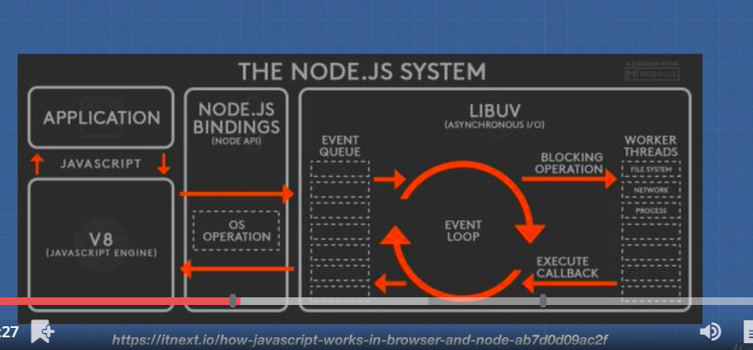

23)Fix this code

See code snippet1. This is related to stack overflow

24)section review

Here one 1 question was asked.